Final Report
Close Approaches: Mapping Near-Earth Asteroids
STAT 53100 Data Analysis
Tanisha Raskar

Index

- Purpose and Background 1
a. Potentially Hazardous Asteroid (PHA) Criteria
b. Description
c. Data Transformation
- Exploratory Data Analysis (EDA) 7
2.1 Summary Statistics
2.2 Distributional Analysis
2.3 Correlation Analysis
2.4 Velocity Analysis: Effect of Earth’s Gravity
2.5 Relationship Between Missed Distance and Brightness
2.6 Asteroid Close Approaches by Year
2.7 EDA Summary
- Comparative Analysis of Hazard-Oriented Groups 14
3.1 Definition of Hazard-like, Near-hazard, and Low-concern Groups
3.2 Distance and Brightness Comparison Across Groups
3.3 Velocity and Gravitational Effects
3.3.1 Group-wise Velocity Comparison
3.3.2 Velocity vs Brightness Patterns
3.4 Prediction Uncertainty Across Groups
3.5 Summary of Group Differences
- Modelling 18
4.1 Classification
4.1.1 Classification Tree in Distance–Brightness Space
4.1.2 Classification Using Only Dynamic and Uncertainty Features
4.2 Clustering
4.2.1 Elbow Plot for k-means
4.2.2 k-means Clusters in Distance–Brightness Space
- Summary of Conclusions 25
  - Conclusion
  - Cautions and Limitations
  - Answers to Research Questions
- Resources and Appendix 29

- Purpose and Background
In Chelyabinsk, Russia on 15th of February 2013, a 20 meter asteroid entered the atmosphere and exploded mid-air. The explosion was around 500 kilotons of TNT that sent a shockwave across the city of Chelyabinsk further shattering thousands of windows of buildings and injuring more than 1600 people. In a matter of a few minutes the celestial event became a public safety incident. Chelyabinsk is now one of the largest asteroid explosions in over a century. This incident highlighted the reality that even relatively small asteroids can have significant effects.
Research about the asteroids claims that smaller asteroids around 10 meters in diameter strike Earth roughly once every decade, producing fireballs strong enough to shatter windows. Larger ones are about 50 meters wide and are expected to hit about once every 1000 years, causing local devastation. When asteroids reach 140 meters, they collide with Earth approximately once every 20000 years forming 1-2 kilometers wide craters and inflicting damage across metropolitan or regional areas such objects are classified as Potentially Hazardous Asteroids (PHAs). One such case is Arizona’s Barringer Crater. The crater is about 1.2 kilometers wide and 180 meters deep. The asteroid that created the crater about 50,000 years ago is thought to have been between 100 to 170 feet (30 to 50 meters) in size. Most of the asteroid melted or vaporized on impact. This shows that planetary defense is a data problem that can help avoid these situations.
Looking at the data collected by NASA about outer space bodies it’s visible to us that apart from the Moon, the Earth’s outer space is crowded with small bodies and debris. Asteroids are a part of these bodies, and they span in a wide range of sizes. Most of them are harmless, some burn up before even reaching the ground due to the Earth’s atmosphere. Yet objects around 4 meters in size (car sized) strike Earth’s atmosphere about once a year, and larger bodies, although rarely, strike Earth and further cause major devastation. Understanding these risks therefore means knowing how size, brightness, speed, and distance help in determining NASA’s potentially hazardous bodies. The project aims to describe how the near-Earth objects are categorized into hazard-like, near-hazard, and low-concern encounters, and to show that, data-driven methods (exploratory analysis, classification trees, and k-means clustering) largely recover the same risk structure as the PHA distance - size criteria.

Research Questions:
- What are the main patterns in approach distance, size (brightness), velocity, and prediction uncertainty for near-Earth asteroid close approaches?
- How do hazard-like, near-hazard, and low-concern encounters differ in terms of distance, size, velocity, and prediction uncertainty?

  - Potential Hazardous Asteroids (PHA) Criterion
Asteroids that approach Earth’s orbit are categorized based on their orbital dynamics and physical properties, which together determine their potential threat level. Using data and classification standards established by NASA’s Near-Earth Object research programs, a Potentially Hazardous Asteroid (PHA) can be identified according to the following criteria:
Minimum orbit intersection distance (MOID): the smallest distance between the asteroid’s orbit and Earth’s orbit. An asteroid is considered potentially hazardous if its MOID is less than or equal to 0.05 AU, which is about 7.48 million kilometers (4.65 million miles). This distance threshold marks the region where gravitational influences could shift the asteroid’s trajectory enough to create a possible impact. Objects within this boundary are therefore monitored closely for any changes in their orbital paths.
Absolute magnitude (h), which estimates its size and brightness. Asteroids with an h value of 22.0 or lower are large enough around 140 meters in diameter or more to cause regional or continental damage if they were to collide with Earth. Smaller and dimmer objects (h > 22) generally disintegrate in the atmosphere or cause limited local damage and are thus not classified as hazardous.
In this project, objects that satisfy both the MOID ≤ 0.05 AU and h ≤ 22 criteria are referred to as hazard-like. Asteroids that fall just outside these criteria, such as those with MOID values slightly above 0.05 AU or h magnitudes between 22 and 25, are treated as near-hazard, since small orbital or gravitational changes could still bring them into hazardous proximity over time. Encounters that are within the near-Earth distance range but involve smaller, dimmer objects are grouped as low concern. Therefore, these criteria enable the detection and comparison of hazard-like, near-hazard, and low-concern objects that might, or might not, pose a meaningful impact risk to Earth.

  - Description
The study uses a Near Earth object (NEO) dataset exported from NASA’s public NEO API (produced by NASA’s Jet Propulsion Laboratory using observations curated by the International Astronomical Union’s Minor Planet Center: Website: https://ssd-api.jpl.nasa.gov/doc/cad.html (Imported dataset: https://ssd-api.jpl.nasa.gov/cad.api?body=Earth&date-min=1900-01-01&date-max=2100-01-01&neo=true )). The file has 39585 rows and 11 variables with each variable segregated into categorical and numerical values.
Following are the variables:
Variable | Type | Unit | Context
des | Categorical | — | The asteroid’s official ID or short name.
orbit_id | Number /Character | — | The version of the asteroid’s orbit is used by NASA to make calculations.
jd | Number | Julian date | A special number used by astronomers to mark time.
cd | Character / Date | Date and time | The actual date and time (in UTC) when the asteroid come closest to Earth.
dist | Number | AU | How far the asteroid gets from Earth during its closest approach. 1 AU = the distance from Earth to the Sun.
dist_min | Number | AU | The smallest possible distance it might get to Earth, based on uncertainty.
dist_max | Number | AU | The largest possible distance it might get to Earth, based on uncertainty.
v_rel | Number | km/s | The asteroid’s speed which is relative to Earth when it passes by.
v_inf | Number | km/s | Its speed when it’s far away from Earth, before Earth’s gravity pulls on it.
t_sigma_f | Character | Days:Hours:Minutes | How uncertain NASA is about the exact timing of the close approach (like “±2 days, 9 hours”).
h | Number | Magnitude | A measure of how bright the asteroid looks — brighter usually means bigger.
uncertainity_hours | Number | Hours and minutes | Added: The estimated variation in the asteroid’s predicted position in hours and minutes, to show orbital uncertainty.
days | Number | — | Added: Indicates the uncertainty duration in days for the asteroid’s closest approach
vel_change | Number | km/s | Added: Measures the difference between near-Earth and far-space velocity, showing how much the asteroid accelerates due to Earth’s gravity by taking a difference (v_rel – v_inf).
year | Number | — | Added: asteroid encounters across years
obs_id | Number | — | Added: unique numeric identifier for each observation.

The dataset has asteroids’ orbital paths, physical characteristics, proximity to Earth and other variables that help us in gaining further insight on how the object is navigating. It focuses on the quantitative aspects (measurable parameters) that define an asteroid’s behavior and potential threat. It has essential information such as orbital distance, velocity, brightness, and estimated size, each contributing to understanding how these celestial bodies interact with Earth’s orbit. By analyzing this data, we can identify patterns that distinguish harmless objects from those posing real danger. The dataset’s structure allows for examining correlations between distance, velocity, and size factors that collectively determine an asteroid’s classification as hazardous. This information not only supports risk assessment and early detection but also contributes to improving predictive models used in planetary defense and impact prevention strategies.

  - Data Transformation
The dataset initially contained raw observational data that required some transformations for analysis. There were a few missing observations in the variables v_inf (22 entries) and h (9 entries), which were replaced with NA values to maintain data consistency. The variable t_sigma_f presented a combined time format with days, hours, and minutes together, which was segregated into two new column uncertainty_hours and days for easier interpretation of the time range within which the asteroid’s trajectory may deflect. The date column was also reformatted into a more standardized format. Modifications were made to the data column by adding vel_change (v_rel – v_inf) to better understand the change in velocity after Earth’s gravitational influence.
While reviewing the dataset, no significant outliers were removed. The few extreme values observed in velocity (v_rel, v_inf) and brightness (h) were retained, as they represent meaningful insights rather than errors. These high or low values correspond to asteroids with special speed, size, or reflectivity helping in understanding of further near-Earth object (NEO) characteristics. Removing them might risk losing critical information about rare and important cases. Overall, the dataset was cleaned to keep the data accurate while making it easier to understand through transformations.
- Exploratory Data Analysis
The purpose of Exploratory analysis was to examine the key characteristics of the Near-Earth object dataset and identify how variables such as velocity, approach distance, and brightness contribute to determining whether an asteroid may be classified as Potentially Hazardous (PHA).
2.1 Summary statistics
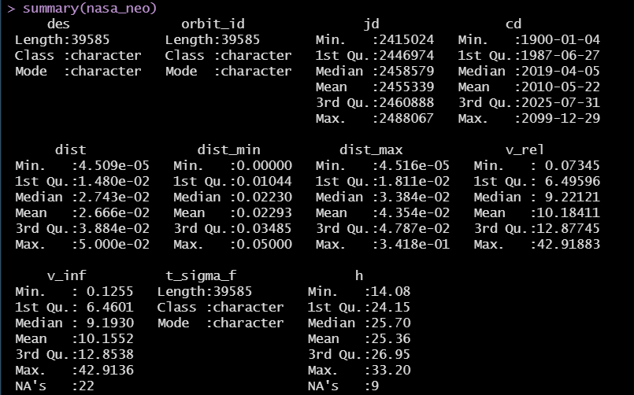
Figure 2.1: Summary statistics

Based on the summary statistics, asteroid distances range between 0.000045 AU, and 0.05 AU have a mean of 0.0266 AU. This indicates that although most asteroids pass at a safe distance, a small subset approaches Earth more closely. Relative velocity (v_rel) values ranged from 0.07 km/s to 42.9 km/s have a mean of 10.18 km/s showing that there is significant variation in asteroid motion. The absolute magnitude (h) ranged from 14.08 to 33.20 has a mean of 25.36 and shows that the dataset includes bright large asteroids and dim smaller ones.

  - Distributional analysis
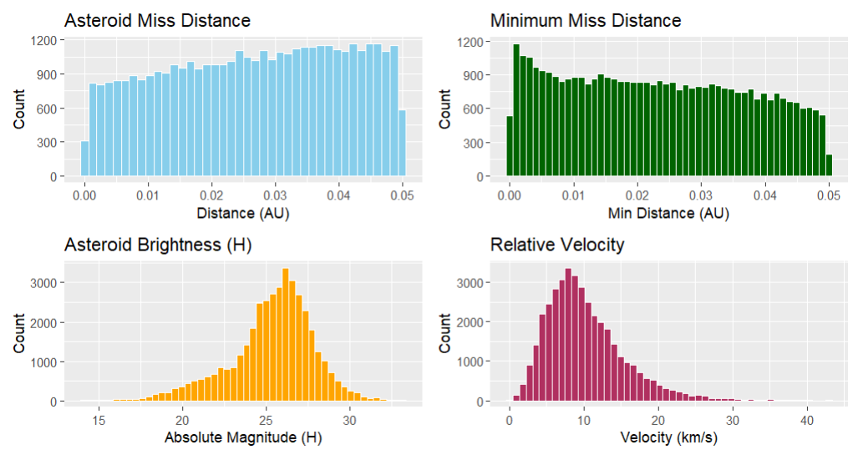
Figure 2.2: Distributional analysis

The histograms for distance, brightness, and velocity provided following insights:
- Asteroid missed distance: The distribution of miss distance by the asteroid is uniform but has an increasing graph, indicating that asteroids pass Earth at a range of distances 0.05 AU. This increases towards larger distances thus showing that most NEOs tend to pass at moderate to far distances while close approaches are comparatively rare.
- Minimum missed distance: The minimum missed distance graph has a right skew, with higher values near 0 AU and a tail towards 0.05 AU. This indicates that although most asteroids do not come very close, there are a few numbers that fall in the near encounters. These can be the ones classified under Potentially Hazardous Asteroids
- Asteroid brightness (h): The absolute magnitude (h) plot is approximately normal since it has a bell-shape curve and is centered around h = 25. Since lower H values indicate greater brightness and larger size, this distribution tells that most observed asteroids are of moderate size, while very large (bright) and very small (dim) objects are less frequent.
- Relative Velocity (v_rel): The distribution of relative velocity is right-skewed, peaking around 9–10 km/s and then reducing towards higher speeds up to 35 km/s. Most asteroids therefore travel at moderate velocities when crossing Earth’s orbit, but the right tail shows a smaller number of fast-moving asteroids that may possess higher impact potential. This is important to further understand how the gravity of the Earth affects Asteroid velocity.

  - Correlation analysis

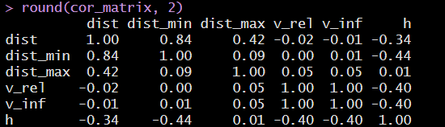
Figure 2.3: Correlation analysis

The correlation matrix highlights several meaningful relationships:
- Distance and Minimum Distance (r = 0.84): Strong positive correlation, showing that both measures move consistently.
- Distance and Absolute Magnitude (r = –0.34 to –0.44): Show a negative correlation, suggesting that brighter (larger) asteroids tend to pass closer to Earth stating that larger objects are easier to detect at closer ranges.
- Velocity (v_rel, v_inf) and Brightness (h): Moderate negative correlations (–0.40) indicate that faster asteroids tend to be dimmer and smaller and hence the smaller bodies are more easily accelerated by the gravitational forces.
- Distance vs. Velocity: Very weak correlation (almost zero), suggesting that distance between the object and the Earth does not necessarily determine the asteroid’s speed.

  - Velocity Analysis: Effect of Earth’s gravity
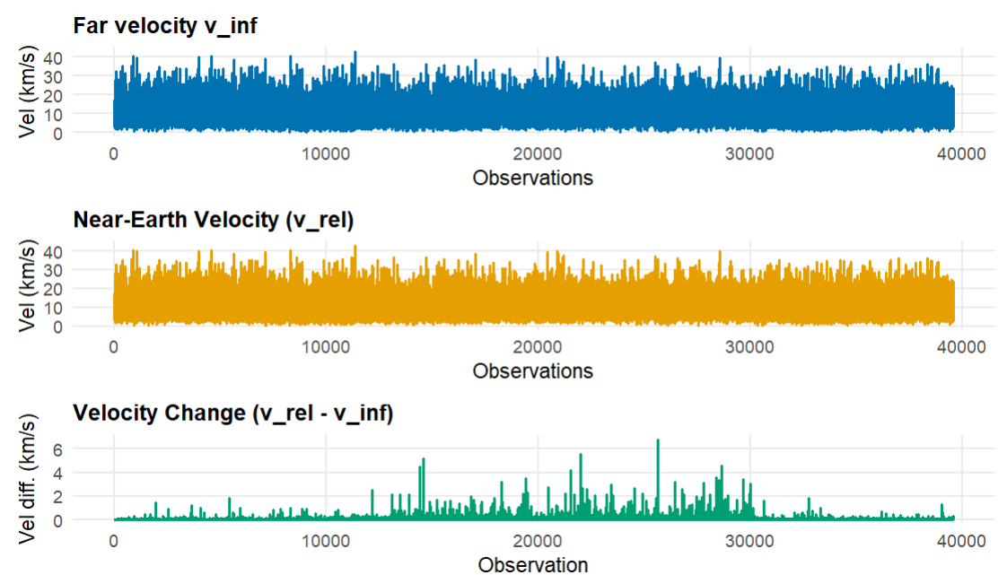
Figure 2.4: Velocity Analysis: Effect of Earth’s gravity

The graph has three types of velocities:
- Far velocity (v_inf)
- Near Earth velocity (v_rel)
- Velocity change (vel_change)
The far velocity plot shows asteroid speeds before entering Earth’s gravitational field, with most values between 0 and 40 km/s. The near-Earth velocity plot has a similar range but has some greater variability showing that the gravitational acceleration increases asteroid velocity when it approaches Earth’s gravity. The velocity change plot shows that most asteroids have small acceleration (under 2 km/s) while as, a few have larger acceleration (4–5 km/s) probably due to passing closely or they have highly elliptical orbits.

  - Relationship between missed distance and brightness
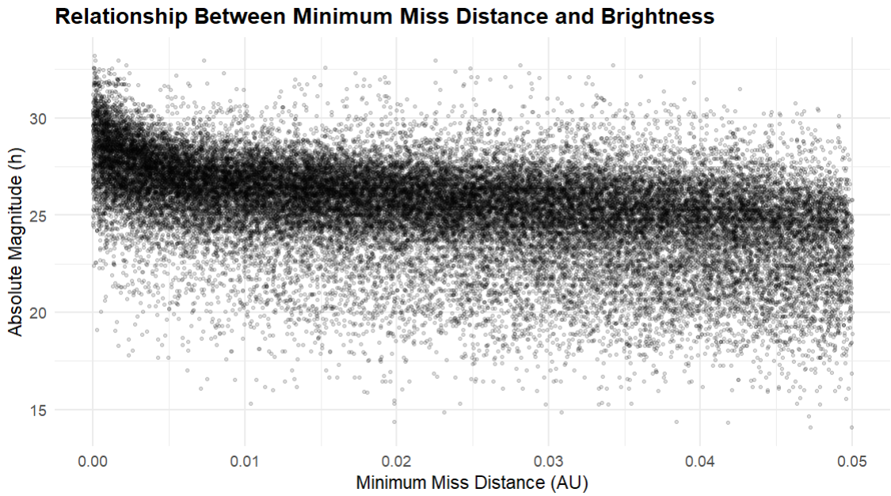
Figure 2.5: Relationship between missed distance and brightness

Based on the scatterplot of minimum miss distance and absolute magnitude, most asteroids cluster around h ≈ 24 - 27 across the full 0 - 0.05 AU range. There is a slight downward trend, meaning that closer encounters tend to include somewhat brighter (larger) objects with lower h values, while farther distances include more dimmer, smaller asteroids with higher h. However, the relationship is weak overall bright asteroids still appear at a range of distances, and many moderate-bright objects are spread throughout the band. This suggests that distance and brightness are related but not in a strict way, and that detection of smaller, dimmer objects likely depends more on them passing close enough to Earth to be observed.

  - Asteroid close approaches by Year

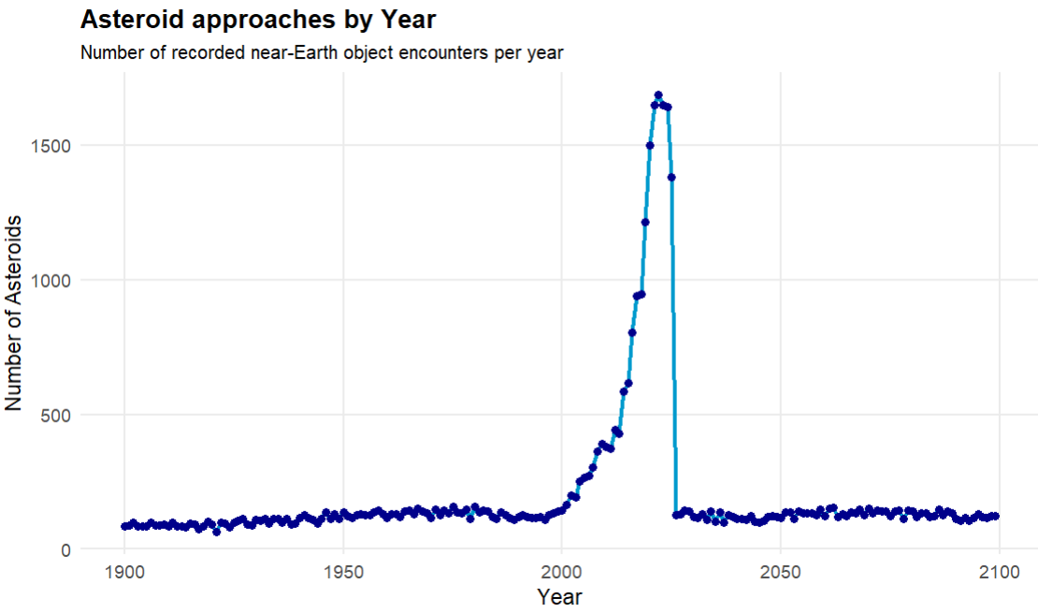
Figure 2.6: Asteroid close approaches by Year

The graph shows that from 1900 to around 1990s, asteroid detections comparatively low constant. A rise is visible in the early 2000s peaking around 2015–2020, after which the findings are again constant. This highlights the importance of detection ways when interpreting the data since earlier years had less findings due to limited observation capacity while as recent years have improved detection efficiency.
  - Summary
Overall distribution of close approaches
The distance summaries and histograms (figure 2.1 and 2.2) indicate that most near-Earth objects pass at relatively comfortable miss distances, with only a small fraction of encounters occurring very close to Earth. The default pattern in the dataset is therefore a large volume of low-risk flybys, with genuinely close approaches forming a much smaller subset.
Prevalence of medium-sized asteroids
The brightness (absolute magnitude: figure 2.2) distribution is approximately bell-shaped around a mid-range value, which implies that there are mostly asteroids of moderate size. Very large objects and extremely small ones are both present but comparatively rare, so the potential for extreme-impact events is concentrated in a relatively small portion of the population.
Speed variation and its limited direct link to risk
Relative velocities cover a broad range and show a right-skewed distribution: most encounters occur at moderate speeds, with fewer very fast events. At the same time, the near-zero correlation between distance and velocity shows that encounter speed, by itself, does not systematically distinguish close approaches from more distant ones. High speed alone is therefore not a sufficient indicator of hazard in this dataset.
Relationship between distance and size
The negative correlation (figure 2.3) between miss distance and brightness, together with the distance-brightness scatterplot, suggests that closer encounters are somewhat more likely to involve brighter, larger objects. However, the relationship is weak and highly overlapped: large asteroids appear at a range of distances, and smaller ones are detected primarily when they pass close enough to be observable. This pattern combines genuine physical structure with observational bias.
Dynamic behavior of smaller bodies
The moderate negative correlation (figure 2.3) between velocity and brightness indicates that smaller, dimmer asteroids tend to exhibit higher velocities or are more easily accelerated. These objects are dynamically more “active,” but because their sizes are small, their individual impact potential remains limited despite their higher speeds.
Effect of Earth’s gravity on encounter speeds
Comparisons of far-field velocity (v_inf) with near-Earth velocity (v_rel) show that Earth’s gravity typically produces only modest increases in speed (figure 2.5). Most encounters exhibit small velocity changes, with larger accelerations appearing only in a minority of very close or dynamically complex passes. Gravitational focusing is present but extreme gravitational effects are uncommon.
Influence of observational capabilities over time
The time-series of detected close approaches reveals a clear rise in the number of recorded events starting in the early 2000s and peaking around 2015–2020 (figure 2.6). This trend aligns with improvements in survey coverage and instrumentation rather than a physical change in the underlying asteroid population, underscoring that the dataset reflects both the true NEO environment and the evolution of detection technology.
- Comparative Analysis of hazard-oriented groups
  - Hazard-oriented groups
To connect the analysis more directly to the PHA criteria, the close approach is classified into three hazard-oriented groups using distance and brightness:
- Hazard-like (n = 4209): encounters that satisfy the PHA-style thresholds (small miss distance and relatively bright, large objects).
- Near-hazard (n = 10681): objects that fall within 0.05 AU but somewhat dimmer/smaller.
- Low concern (n = 24686): encounters that are within 0.05 AU range and are smaller distant relative to the PHA thresholds.
These groups are derived from the same distance–brightness logic used to define Potentially Hazardous Asteroids but are used here only as descriptive categories to compare how size, speed, and uncertainty behave for more and less concerning encounters.
  - Distance & Brightness Comparison
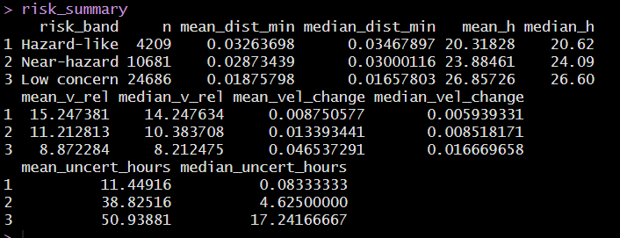
Figure 3.2: Distance & Brightness Comparison
The hazard-like encounters have much brighter (and therefore larger) asteroids on average (h around 20), near-hazard objects are moderately bright (h around 24), and low-concern encounters are dominated by dim, small objects (h around 27). Interestingly, the lowest average miss distance actually occurs in the low-concern group, not the hazard-like group.
This reflects the fact that many very small asteroids pass extremely close to Earth without qualifying as hazard-like because their size is too small to cause large-scale damage.
  - Velocity and Gravitational Effects
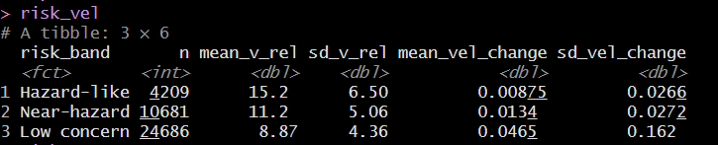
Figure 3.3.1 : Risk velocity
3.3.1 Risk Velocity
The three groups show clear differences in speed. Hazard-like encounters are, on average, substantially faster (mean v_rel ≈ 15 km/s) than low-concern encounters (approx. ≈ 9 km/s), with near-hazard objects in between. This means that hazard-like events not only involve larger bodies but also tend to carry higher kinetic energy potential if an impact were to occur.
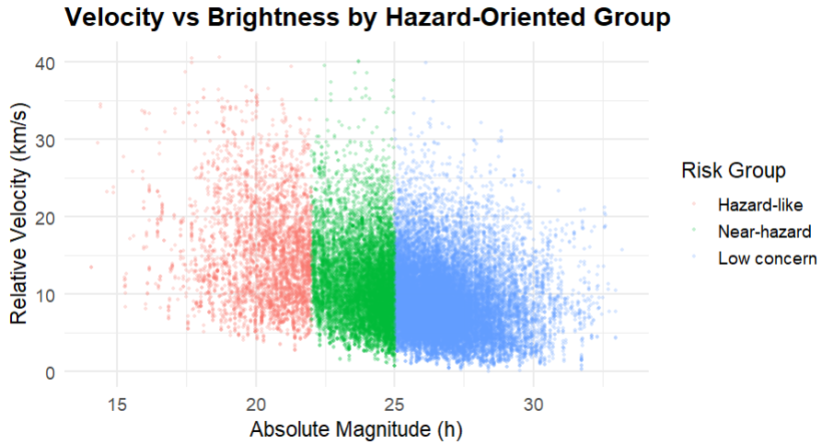
Figure 3.3.2 : Velocity vs brightness plot
3.3.2 Velocity vs brightness plot:
- Hazard-like points (red) occupy the bright, low-H region (roughly h: 18–22) but span a wide range of velocities from slow to very fast.
- Near-hazard (green) sit between h ≈ 22–25, again with a broad vertical spread in v_rel.
- Low-concern (blue) cluster at higher h ≈ 25–32.
The behavior of velocity change is more subtle. Low-concern objects show the largest mean and variability in v_rel − v_inf, indicating that small objects can experience relatively large fractional changes in speed as they pass by Earth, even if their absolute speed remains moderate. For hazard-like and near-hazard encounters, velocity change is small on average, suggesting that these larger bodies tend to follow more stable trajectories through the encounter window.
  - Prediction uncertainty
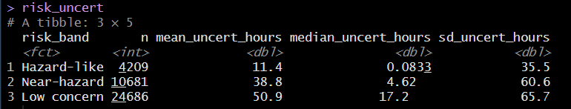
Figure 3.4: Prediction uncertainty
Timing uncertainty shows a very clear gradient across the groups. Hazard-like encounters have the smallest typical uncertainty, with a median of only about five minutes, indicating that the timing of their closest approach is known very precisely. Near-hazard objects have a median uncertainty of a few hours, while low-concern encounters often have uncertainties on the order of many hours to almost a day. The large gap between the median values suggests that larger objects are systematically followed more closely, leading to tighter orbital solutions.
From a planetary-defense point of view, this is reassuring that the encounters that matter most in terms of distance and size are also the ones for which predictions are most accurate, while less threatening small objects are allowed to have looser timing constraints. The long right tails in mean uncertainty for near-hazard and low-concern groups indicate that there are still some poorly constrained cases in the catalog, but these are concentrated among the smaller, dimmer objects.
  - Summary
To summarize, across the three groups, Hazard-like asteroids are generally faster and brighter, so they carry higher potential impact energy, while low-concern objects are smaller, dimmer, and often slower, even though all groups overlap in speed. Low-concern bodies show the largest fractional changes in velocity, whereas hazard-like and near-hazard objects follow more stable trajectories, and timing uncertainty forms a clear gradient precise to within minutes for hazard-like, a few hours for near-hazard, and much looser for low-concern encounters. This pattern is reassuring from a planetary-defense perspective: the objects that pose the greatest potential threat are also the ones whose orbits and close-approach times are known most accurately.

- Modelling
  - Classification
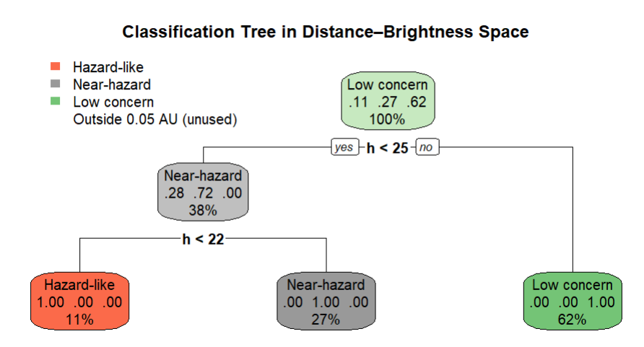
Figure 4.1.1: Classification tree in distance-brightness space

4.1.1 Classification tree in distance-brightness space
To formalize how the three risk groups separate in the distance - brightness plane, I fit a classification tree with the hazard-oriented category (hazard-like, near-hazard, low concern) as the response and two predictors: minimum miss distance (dist_min) and absolute magnitude (h). I restricted the sample to encounters within 0.05 AU so that the tree focuses on close approaches that are relevant for the PHA criteria.
The fitted tree is entirely driven by brightness. At the root node, the data are mostly low concern (about 62%), with near-hazard and hazard-like objects making up roughly 27% and 11% respectively. The first split is on absolute magnitude at around h = 25. Objects with $h≥25$are classified directly as low concern, because this region is dominated by small, dim asteroids that almost never fall into the hazard-like or near-hazard categories. This branch captures the background population of tiny bodies that pass near Earth but, even at close distances, do not carry enough impact energy to be classed as higher risk.
The tree makes a second split at around h = 22. Below this threshold ($h<22$), the node is almost entirely hazard-like and is predicted as such. These are the larger, brighter asteroids that are both close and big enough to be treated as potentially hazardous. In the intermediate brightness range ($22≤h<25$), the terminal node is almost entirely near-hazard. These objects are just below the size/brightness cut used for hazard-like, so they are still of interest but do not fully meet the more conservative PHA threshold.
Most notably, distance does not appear in the tree at all. Once the sample is restricted to encounters within 0.05 AU, variation in dist_min does not provide additional separation beyond what is already captured by brightness. The classification is essentially a three-level size gradient: large close objects (hazard-like), slightly smaller but still close objects (near-hazard), and very small bodies (low concern). The tree achieves perfect classification on the labelled data (100% accuracy), which reflects the fact that the risk bands themselves were defined using these brightness ranges. The tree gives a clean visual summary of how the groups are organized: within the close-approach window, the three risk levels are almost entirely a function of size.

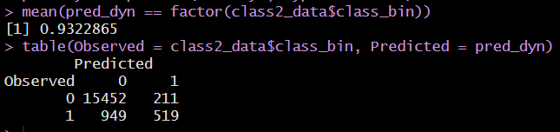
Figure 4.1.2: Classification tree matrix

4.1.2 Classification tree matrix
In terms of performance, the dynamic-only tree correctly classifies about 93.2% of the encounters overall. Out of 15,663 low-concern cases, 15,452 are correctly identified (true negatives) and 211 are incorrectly flagged as hazard-like, giving a very high specificity of around 98.7%. For the 1,468 hazard-like encounters, only 519 are correctly identified as hazardous, while 949 are misclassified as low concern. This corresponds to a sensitivity of around 35% and a precision of about 71% for the hazard-like class. So, the model works very well at recognizing low-concern objects but misses most of the genuinely hazard-like ones, showcasing that dynamic and uncertainty features on their own do not provide a reliable hazard detector without distance and size.
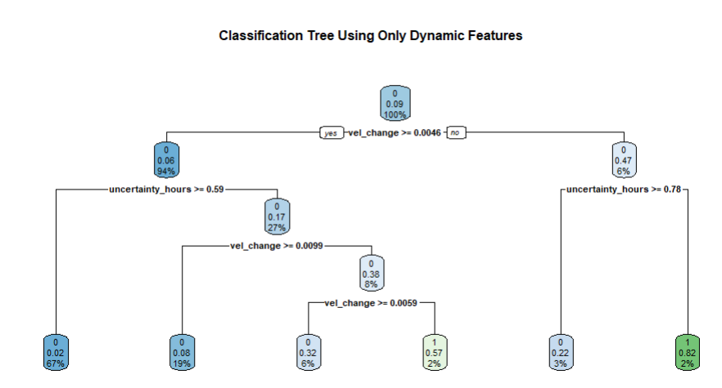
Figure 4.1.3: Classification Using Only Dynamic and Uncertainty Features

4.1.3 Classification using only dynamic and uncertainty features
The second classification model focuses on whether hazardous and low-concern encounters can still be distinguished when distance and size are omitted, relying only on dynamical behavior and prediction uncertainty. To understand this, the data is restricted to hazard-like and low-concern encounters and fit a classification tree with:
- relative velocity (v_rel),
- gravitational speed-up (vel_change = v_rel − v_inf), and
- timing uncertainty (uncertainty_hours)
as predictors. Distance and brightness were intentionally excluded so that the model relies only on how the asteroid moves and how well its orbit is known.
The resulting tree is much less decisive than the distance–brightness tree. At the root, the first split is on velocity change: encounters with larger vel_change (≥ about 0.0046 km/s) are sent down one branch, while those with smaller velocity change go to the other. Most of the data falls on the high vel_change side, and almost all of those observations are classified as low concern after a few further splits on uncertainty_hours and vel_change. This part of the tree reflects that there are small bodies whose dynamical behavior may vary but are still unlikely to be hazardous.
On the branch with very small velocity change, the tree uses timing uncertainty to carve get a small region where hazard-like encounters are more common. When vel_change is very small and uncertainty_hours is relatively large (above roughly 0.8 hours in this fit), the terminal node is predicted as hazard-like, with hazard-like encounters making up the majority within that leaf. This corresponds to a subset of close approaches where the gravitational influence is small, but the orbit is still somewhat uncertain, and where hazard-like objects show up more frequently than low-concern ones. However, this region is tiny compared to the overall dataset.
In terms of performance, the dynamic-only tree achieves an overall accuracy of about 93%. The classifier is very good at recognizing low-concern encounters (it correctly labels roughly 99% of them), largely because low-concern objects are much more common. For hazard-like encounters, the picture is different: only about one-third of hazard-like cases are correctly identified, and the remaining two-thirds are misclassified as low concern. The model therefore rarely calls something hazardous unless the dynamic pattern is very strong, but in doing so it misses a large fraction of genuinely hazard-like objects.
In conclusion, this highlights that when distance and brightness are removed, the dynamic and uncertainty features do not carry enough information on their own to reliably distinguish hazardous from low-concern encounters. They can pick up a narrow subset of hazard-like events, but the separation is weak and highly localized in feature space. The main structure of the risk landscape is still governed by how close the object gets and how big it is, while velocity and prediction uncertainty act more as secondary modifiers that adjust the level of concern once distance and size are known.

  - Classification
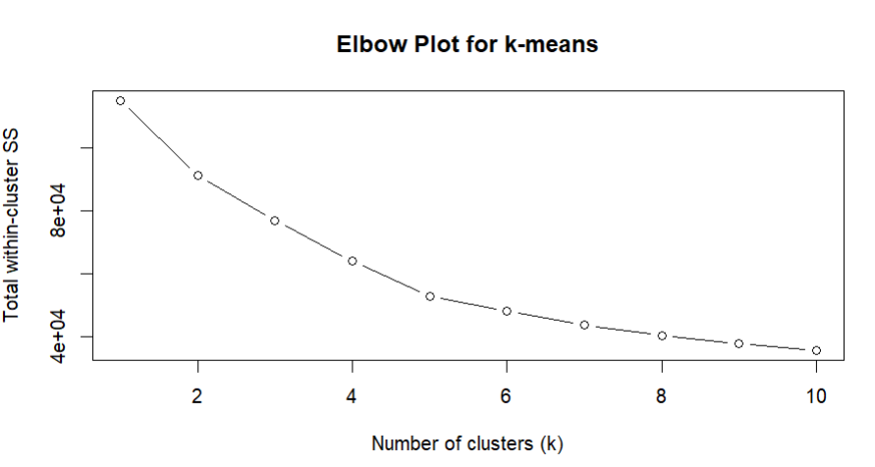
Figure 4.2.1: Elbow Plot for k-means

4.2.1 Elbow Plot for k-means
The elbow plot shows the total within-cluster sum of squares as the number of clusters $k$ increases from 1 to 10. The curve drops steeply from $k=1$to about $k=3$, and then the decrease becomes much more gradual after $k=3$.
- The knee around k = 3 indicates that going from 1 to 2 to 3 clusters captures a large amount of the structure in the distance - brightness space.
- Beyond 3 clusters, each additional cluster only yields a relatively small improvement in within-cluster variation.
So, choosing k = 3 is a reasonable balance: it gives a meaningful partition of the risk space without over-fragmenting the data.
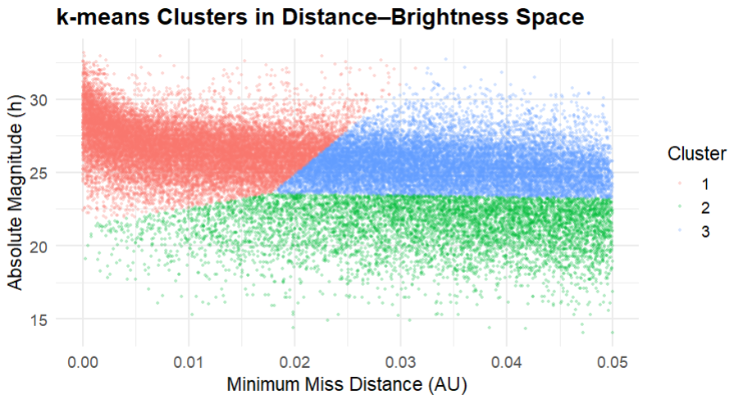
Figure 4.2.2: k-means Clusters in Distance - Brightness Space

4.2.2 k-means Clusters in Distance - Brightness Space
The scatterplot shows the three k-means clusters in the plane of minimum miss distance (dist_min, x-axis) and absolute magnitude (h, y-axis):
- Cluster 2 (green) These objects are consistently brighter and therefore larger (h ≈ 15–24) but span a wide range of distances from very close to 0.05 AU. This is the large-object cluster and is the part of the space most consistent with hazard-like encounters.
- Cluster 1 (red) occupies the upper region of the plot with high h values (dim, small objects) across all distances, including some extremely close passes. This cluster represents small, faint asteroids, some of which can still come very close to Earth but carry much less impact energy.
- Cluster 3 (blue) fills a middle band at intermediate brightness (roughly h ≈ 23–28), mainly at moderate to larger miss distances (dist_min ≳ 0.017 AU). These are medium-size objects that do not get as close as the red cluster’s closest passes and are generally less extreme than the large, bright green cluster.
The pattern shows that k-means, using only distance and brightness, naturally separates the NEO population into:
- a large-object strip (green) that aligns with where hazard-like and near-hazard objects are expected to lie,
- a small, dim population (red), including many very close but low-impact encounters, and
- an intermediate layer (blue) of medium-size objects at moderate distances
To sum up, the elbow plot suggests that three clusters are enough to capture the main structure in the distance - brightness space without overcomplicating it. With $k=3$, k-means separates the data into a group of large, bright objects, a group of small, dim objects, and a middle group of medium-size asteroids at moderate distances. The large, bright group lines up with where hazard-like and near-hazard encounters mostly fall, while the small, dim group contains many very close but low-impact passers. This shows that even using only distance and brightness, the data already separate into risk-relevant layers.

- Summary of Conclusions
  - Conclusions
- The dataset is dominated by low-risk passing asteroids: most near-Earth objects pass at comfortable miss distances, and truly close encounters are a small minority.
- Most detected asteroids are medium-sized; very large impactors and tiny fragments both exist but are relatively rare, so the highest-impact risk is concentrated in a small subset of objects.
- Exploratory analysis and the hazard-group comparisons both show that potential hazard is where distance and size intersect: objects that are both close and relatively large/bright.
- Many very small asteroids can pass extremely close to Earth but still fall into the low-concern group because they cannot cause large-scale damage.
- Speed varies widely, but velocity alone does not separate safe from risky encounters; it modifies impact energy but does not define the hazardous region by itself.
- Smaller, dimmer asteroids tend to be dynamically more active (higher speeds and larger fractional velocity changes) but remain low impact individually because of their size.
- Larger, brighter hazard-like objects show more stable trajectories with smaller velocity changes through the Earth encounter window, but they carry much higher potential energy if an impact were to occur.
- Timing uncertainty shows a clear gradient across risk levels:
  - Hazard-like: closest approaches are typically known to within minutes.
  - Near-hazard: uncertainties are on the order of hours.
  - Low concern: uncertainties can extend to many hours to almost a day.
- This pattern suggests that larger, more consequential objects are systematically followed more closely, while smaller low-risk bodies are allowed to remain more uncertain.
- The strong rise in detections after the early 2000s reflects improved surveys and instrumentation, showing that the catalog is shaped by both the true asteroid environment and our observing capabilities.
- Distance never appears in the tree once we restrict to close approaches, and the tree perfectly reproduces the hazard bands, confirming that within this window, size/brightness is the primary driver of how risk levels are assigned.
- When distance and brightness are removed and only velocity, velocity change, and timing uncertainty are used, the classifier is very accurate for low-concern encounters, but correctly identifies only about one-third of hazard-like cases, showing that dynamic and uncertainty features cannot reliably detect hazard on their own.
- The elbow plot shows that three clusters are enough to capture the main structure in distance–brightness space without overfitting.
  - a large, bright cluster that aligns with hazard-like and near-hazard encounters,
  - a small, dim cluster that includes many very close but low-impact flybys,
  - a middle group of medium-size objects at moderate distances.
- This means that even without using hazard labels, the data naturally organize into risk-relevant layers, with a compact region of larger, more consequential objects embedded in a much larger background of small, mostly low-concern asteroids.
  - Limitations
Simplified hazard definition
The hazard-oriented groups are based only on miss distance and brightness (size). They do not account for full orbital evolution, long-term impact probabilities, or physical properties such as density, composition, or entry angle, which all affect true impact risk.
Limited feature set and static snapshot
The analysis uses a small set of kinematic and geometric variables from close-approach records. It does not incorporate full dynamical modelling over time, multiple encounters, or interactions with other bodies, so it captures only a fraction rather than long-term behavior.
Model assumptions and scope
Methods such as classification trees and k-means clustering assume relatively simple decision boundaries and Euclidean structure in the feature space. The models are descriptive and exploratory, not operational prediction tools, and their conclusions should be interpreted as patterns in this dataset, not as formal planetary-defense thresholds.
  - Final answers to the questions
- What are the main patterns in approach distance, size (brightness), velocity, and prediction uncertainty for near-Earth asteroid close approaches?
- Distance:
Most close approaches are at moderate miss distances within 0.05 AU, with only a small fraction coming very close to Earth. So, the default behavior in the dataset is many low-risk passers and relatively few genuinely close encounters.
- Size / brightness (h):
The brightness distribution is roughly bell-shaped around h ≈ 25, meaning the dataset is dominated by medium-sized asteroids. Very large and very small objects exist but are rare, so the potential for extreme damage is concentrated in a small subset.
- Velocity:
Relative velocities span a wide range and are right-skewed: most objects travel at moderate speeds (~9–10 km/s), with fewer very fast encounters. Distance and velocity are almost uncorrelated, so speed by itself does not distinguish close from distant passes.
- Prediction uncertainty:
Timing uncertainty varies widely. Some encounters are known to within minutes, while others have uncertainties of many hours or more. This uncertainty is not uniform: larger, brighter objects tend to have tighter timing estimates, while small, dim ones are more loosely constrained.

- How do hazard-like, near-hazard, and low-concern encounters differ in terms of distance, size, velocity, and prediction uncertainty?
Hazard-like, near-hazard, and low-concern encounters differ clearly in size, speed, and how well they are tracked. Hazard-like encounters involve the largest and brightest asteroids (lower h, around 20), while near-hazard objects are moderately bright (around h ≈ 24), and low-concern encounters are dominated by small, dim bodies (h ≈ 27 and higher). Interestingly, many of the closest passes in terms of distance actually belong to the low-concern group, showing that very small asteroids can come extremely close to Earth without being considered truly hazardous because their size is too small to cause large-scale damage. In terms of speed, hazard-like objects are faster on average, near-hazard objects sit in the middle, and low-concern asteroids are generally slower, although all three groups overlap in velocity. Velocity change is largest and most variable for low-concern objects, suggesting that small bodies can experience relatively large fractional changes in speed near Earth, whereas hazard-like and near-hazard objects tend to follow more stable trajectories. Prediction uncertainty forms a clear gradient: hazard-like encounters are timed most precisely (often within minutes), near-hazard encounters are known to within a few hours, and low-concern encounters have the loosest timing, sometimes spanning many hours to almost a day.

- Resources and Appendix
https://www.esa.int/Space_Safety/Russia_asteroid_impact_ESA_update_and_assessment
https://science.nasa.gov/solar-system/asteroids/facts/
https://earthobservatory.nasa.gov/images/148384/arizonas-meteor-crater
https://www.nasa.gov/wpcontent/uploads/2015/12/nasem_report_finding_hazardous_asteroids.pdf
https://ssd-api.jpl.nasa.gov/doc/cad.html
https://ssd-api.jpl.nasa.gov/cad.api?body=Earth&date-min=1900-01-01&date-max=2100-01-01&neo=true
Appendix A: Data Import and Preparation
library(jsonlite)
library(readr)
library(tidyverse)
library(lubridate)
# API endpoint: Earth close-approaches for NEOs (1900–2100)
url <- "https://ssd-api.jpl.nasa.gov/cad.api?body=Earth&date-min=1900-01-01&date-max=2100-01-01&neo=true"
# Fetch and convert JSON
neo_raw <- fromJSON(url)
nasa_neo <- as.data.frame(neo_raw$data, stringsAsFactors = FALSE)
colnames(nasa_neo) <- neo_raw$fields
# Clean blanks / "null" and convert numeric columns
nasa_neo <- nasa_neo %>%
mutate_all(~na_if(., "")) %>%
mutate_all(~na_if(., "null")) %>%
mutate(
jd = as.numeric(jd),
dist = as.numeric(dist),
dist_min = as.numeric(dist_min),
dist_max = as.numeric(dist_max),
v_rel = as.numeric(v_rel),
v_inf = as.numeric(v_inf),
h = as.numeric(h)
)
# Velocity change and date-time
nasa_neo <- nasa_neo %>%
mutate(
vel_change = v_rel - v_inf,
cd_dt = as.POSIXct(cd, format = "%Y-%b-%d %H:%M", tz = "UTC"),
year = year(cd_dt)
)

Appendix B: Exploratory Data Analysis Code
B.1 Summary Statistics and Missing Values
# Missing values overview
nasa_neo %>%
summarise_all(~sum(is.na(.))) %>%
pivot_longer(everything(),
names_to = "Variable",
values_to = "Missing_Count") %>%
mutate(Missing_Percent = round(Missing_Count / nrow(nasa_neo) * 100, 2))
# Numeric summaries
nasa_neo %>%
select(jd, dist, dist_min, dist_max, v_rel, v_inf, h) %>%
summary()

B.2 Histograms for Key Variables
library(ggplot2)
library(patchwork)
p1 <- ggplot(nasa_neo, aes(x = dist)) +
geom_histogram(bins = 40, fill = "skyblue", color = "white") +
labs(title = "Asteroid Miss Distance", x = "Distance (AU)", y = "Count")

p2 <- ggplot(nasa_neo, aes(x = dist_min)) +
geom_histogram(bins = 50, fill = "darkgreen", color = "white") +
labs(title = "Minimum Miss Distance", x = "Min Distance (AU)", y = "Count")
p3 <- ggplot(nasa_neo, aes(x = h)) +
geom_histogram(bins = 50, fill = "orange", color = "white") +
labs(title = "Asteroid Brightness (h)", x = "Absolute Magnitude (h)", y = "Count")
p4 <- ggplot(nasa_neo, aes(x = v_rel)) +
geom_histogram(bins = 50, fill = "maroon", color = "white") +
labs(title = "Relative Velocity", x = "Velocity (km/s)", y = "Count")
(p1 | p2) / (p3 | p4)

B.3 Correlation Matrix
library(GGally)
neo_numeric <- nasa_neo %>%
select(dist, dist_min, dist_max, v_rel, v_inf, h) %>%
drop_na()
cor_matrix <- cor(neo_numeric)
round(cor_matrix, 2)

B.4 Yearly Close Approaches
asteroid_yearly <- nasa_neo %>%
filter(!is.na(year)) %>%
group_by(year) %>%
summarise(count = n(), .groups = "drop")
ggplot(asteroid_yearly, aes(x = year, y = count)) +
geom_line(color = "deepskyblue3", linewidth = 1.3) +
geom_point(color = "darkblue", size = 2) +
labs(
title = "Asteroid Approaches by Year",
subtitle = "Number of recorded near-Earth object encounters per year",
x = "Year", y = "Number of Asteroids"
) +
theme_minimal(base_size = 14)
B.5 Distance–Brightness Relationship
neo_bd <- nasa_neo %>%
filter(!is.na(dist_min), !is.na(h))
ggplot(neo_bd, aes(x = dist_min, y = h)) +
geom_point(alpha = 0.15, size = 0.9) +
labs(
title = "Relationship Between Minimum Miss Distance and Brightness",
x = "Minimum Miss Distance (AU)",
y = "Absolute Magnitude (h)"
) +
theme_minimal(base_size = 14)

Appendix C: Hazard Groups and Group Summaries
# Summary by hazard-oriented risk band
risk_summary <- nasa_neo %>%
filter(risk_band %in% c("Hazard-like", "Near-hazard", "Low concern")) %>%
summarise(
n = n(),
mean_dist_min = mean(dist_min, na.rm = TRUE),
mean_h = mean(h, na.rm = TRUE),
mean_v_rel = mean(v_rel, na.rm = TRUE),
mean_vel_change = mean(vel_change, na.rm = TRUE),
mean_uncert_hours = mean(uncertainty_hours, na.rm = TRUE),
.by = risk_band
)

risk_summary

ggplot(
nasa_neo %>% filter(risk_band %in% c("Hazard-like", "Near-hazard", "Low concern")),
aes(x = h, y = v_rel, color = risk_band)
) +
geom_point(alpha = 0.25, size = 0.7, shape = 16) +
labs(
title = "Velocity vs Brightness by Hazard-Oriented Group",
x = "Absolute Magnitude (h)",
y = "Relative Velocity (km/s)",
color = "Risk Group"
) +
theme_minimal(base_size = 14)
Appendix D: Clustering Code (k-means)
vars <- c("dist_min", "h", "v_rel", "vel_change", "uncertainty_hours")
clust_data <- nasa_neo %>% select(all_of(vars)) %>% na.omit()
clust_scaled <- scale(clust_data)
# Elbow plot
set.seed(123)
wss <- sapply(1:10, function(k) {
kmeans(clust_scaled, centers = k, nstart = 20)$tot.withinss
})
plot(1:10, wss, type = "b",
xlab = "Number of clusters (k)",
ylab = "Total within-cluster SS",
main = "Elbow Plot for k-means")
# k = 3 in distance–brightness space
risk_space <- nasa_neo %>%
select(dist_min, h) %>%
na.omit()
risk_scaled <- scale(risk_space)
set.seed(123)
k3_risk <- kmeans(risk_scaled, centers = 3, nstart = 50)

risk_space$cluster_risk <- factor(k3_risk$cluster)

ggplot(risk_space, aes(x = dist_min, y = h, color = cluster_risk)) +
geom_point(alpha = 0.3, size = 0.6, shape = 16) +
labs(
title = "k-means Clusters in Distance–Brightness Space",
x = "Minimum Miss Distance (AU)",
y = "Absolute Magnitude (h)",
color = "Cluster"
) +
theme_minimal(base_size = 14)
Appendix E: Classification Code
E.1 Classification Tree in Distance–Brightness Space
library(rpart)
library(rpart.plot)

class_data <- nasa_neo %>%
filter(risk_band %in% c("Hazard-like", "Near-hazard", "Low concern")) %>%
select(risk_band, dist_min, h) %>%
na.omit()

set.seed(123)
tree_risk <- rpart(
risk_band ~ dist_min + h,
data = class_data,
method = "class",
control = rpart.control(cp = 0.001, minbucket = 200)
)

rpart.plot(tree_risk, main = "Classification Tree in Distance–Brightness Space")

pred_tree <- predict(tree_risk, type = "class")
mean(pred_tree == class_data$risk_band)
table(Observed = class_data$risk_band, Predicted = pred_tree)
E.2 Classification Using Only Dynamic and Uncertainty Features
class2_data <- nasa_neo %>%
filter(risk_band %in% c("Hazard-like", "Low concern")) %>%
mutate(class_bin = if_else(risk_band == "Hazard-like", 1, 0)) %>%
select(class_bin, v_rel, vel_change, uncertainty_hours) %>%
na.omit()

set.seed(123)
tree_dyn <- rpart(
factor(class_bin) ~ v_rel + vel_change + uncertainty_hours,
data = class2_data,
method = "class",
control = rpart.control(cp = 0.001, minbucket = 200)
)

rpart.plot(tree_dyn, main = "Classification Tree Using Only Dynamic Features")

pred_dyn <- predict(tree_dyn, type = "class")
mean(pred_dyn == factor(class2_data$class_bin))
table(Observed = class2_data$class_bin, Predicted = pred_dyn)

